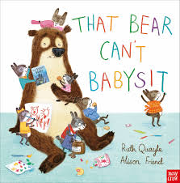**baby**  
Sandra had a baby (= gave birth to it) on 29 May.  
Oh baby, I love you.  
Their baby was born last December.  
She wrapped the baby in a blanket.

**babysit**  
  
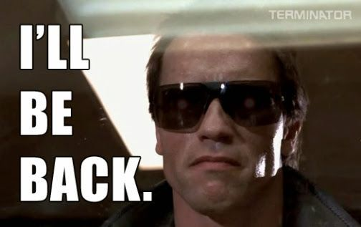I babysit for Jane on Tuesday evenings while she goes to her yoga class.

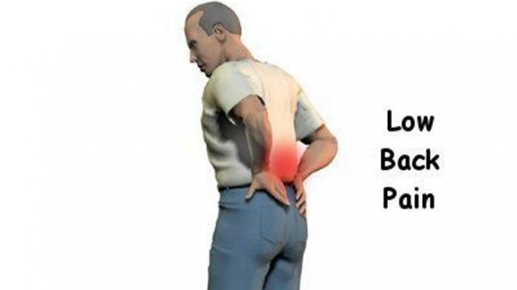

**back**

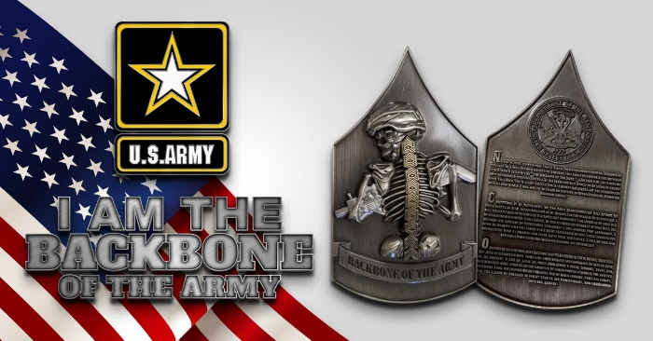I’ll be back in a minute.  
I feel like going back to bed.  
He was back home by half-past eleven.  
We ought to try and get back before it gets dark.  
Can I call you back later?  
I’ll pay you back on Friday.

He kissed her on the back of her head.  
The answers are in the back of the book.  
The sports pages are usually at the back.  
I keep my keys in my back pocket.

Sleeping on a bed that is too soft can be bad for your back.  
He lay on his back, staring at the ceiling.

|  |
| --- |
| **backbone** |

Farming is the backbone of the country's economy.  
The non-commissioned officer corps is often referred to as "the backbone" of the armed services, as they are the primary and most visible leaders for most military personnel.  
**NCO's are the backbone of the Army.**

|  |
| --- |
| **backfire** |

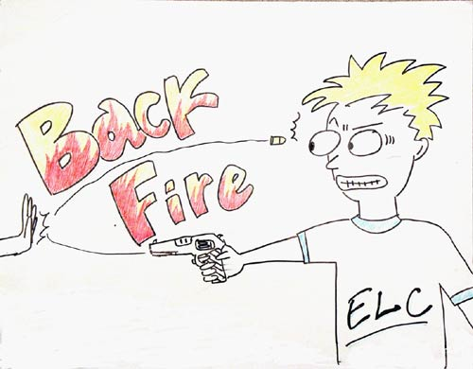***(of a plan) to have the opposite result from the one you intended:***  
Her plans to make him jealous backfired on her when he started dating her best friend.  
The company’s new policy backfired when a number of employees threatened to quit.  
Trying to make your partner jealous by flirting with other people can easily backfire on you.

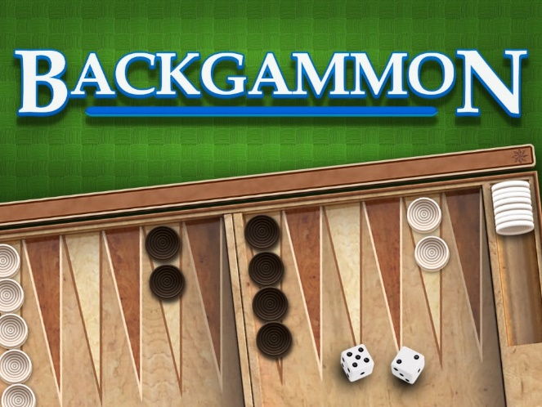

|  |
| --- |
| **backgammon** |

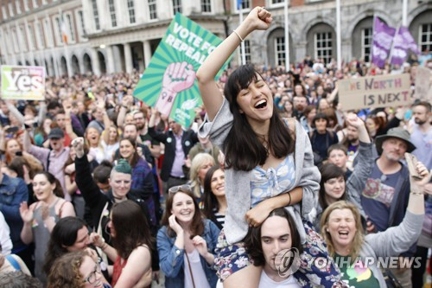She doesn't consider herself a professional backgammon player.

|  |
| --- |
| **backlash** |

***a strong negative reaction by a number of people against recent events, especially against political or social developments***  
***backlash against***  
The 1970s saw the first backlash against the women’s movement.  
The management fear a backlash from fans over the team’s poor performances.  
The mayor foresaw no political backlash against his proposal.

|  |
| --- |
| **backwards** |

Hannah took a step backward.  
She pushed me and I fell backwards into the chair.  
Count backwards from 100.  
Can you say the alphabet backwards?  
He took a step backwards to allow her to pass.  
He began counting backwards: "Ten, nine, eight..."

|  |
| --- |
| **bad  ≠ good** |

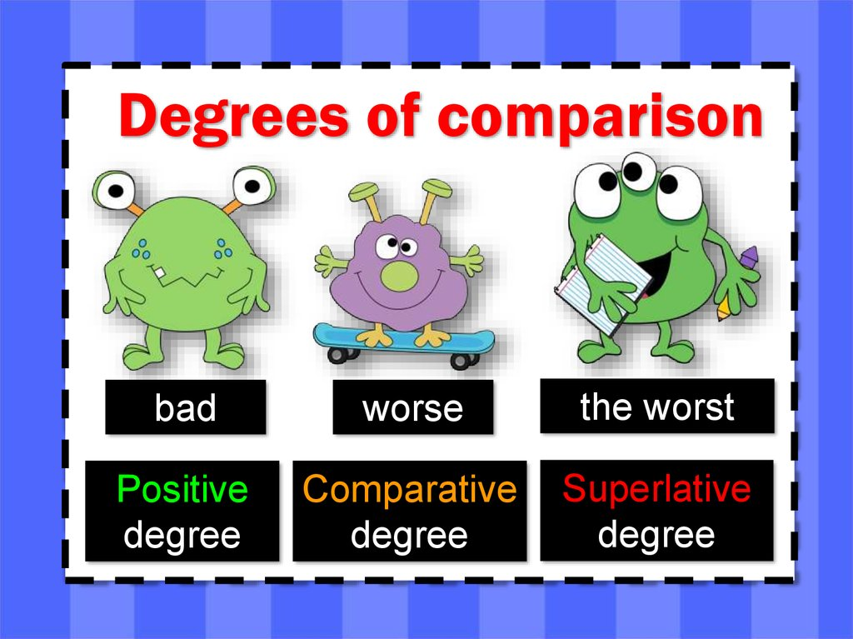Our holiday was spoiled by bad weather.  
We've just had some very bad news.  
I had a very bad night (= did not sleep well) last night.  
Watch out - he's in a bad mood (= being unpleasant to everyone).  
He has some very bad habits.

|  |
| --- |
| **my bad** |

***used for saying that you accept that you are wrong or that something is your fault:***  
"You brought the wrong book." "Okay, my bad. I'll go get it."



|  |
| --- |
| **baffle** |

Her behavior baffled her parents.  
She was completely baffled by his strange behaviour.  
Even his friends were baffled by his behavior.

|  |
| --- |
| **bag** |

I put a few personal belongings in a bag and left the house for the last time.  
She suddenly remembered (that) her keys were in her other bag.  
Just throw your bags in the back of the car.  
Hey, don't forget your school bag!  
The supermarket no longer gives free carrier bags.



|  |
| --- |
| **bake : pişirmek** |

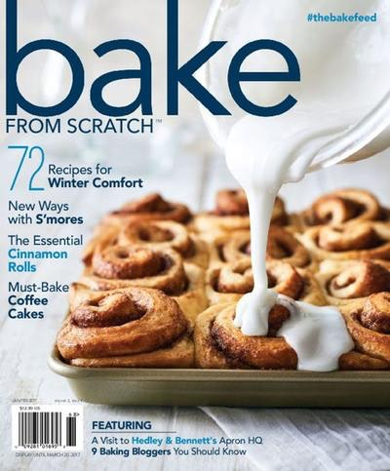***to cook inside an oven, without using added liquid or fat:***

You'll bake in that fleece jacket! It's baking outside.  
Bake at 180°C for about 20 minutes.

|  |
| --- |
| **baker** |

***a person whose job is to make bread and cakes for sale, or to sell bread and cakes***

(also **baker's**) a shop where bread and cakes are sold and sometimes made

I went to the baker **for** some bread.  
I went to the baker, **for** I needed some bread.

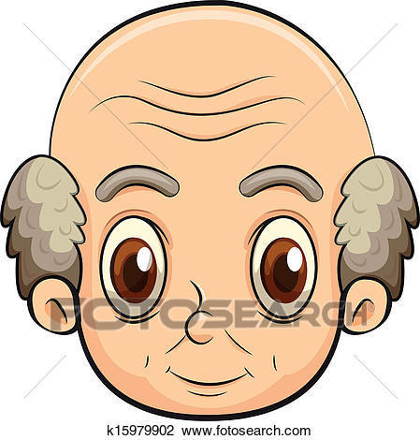

|  |
| --- |
| **bald** |

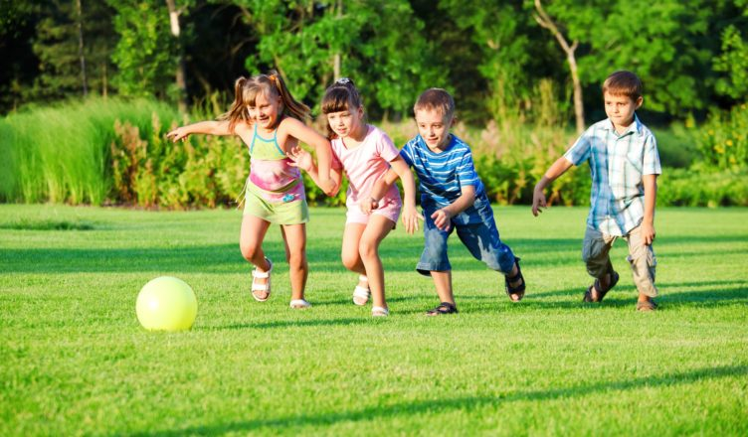He's overweight and bald, and yet somehow, he's incredibly attractive.  
At 20 he was already going bald.  
The idea of going grey doesn't bother me, but I'd hate to go bald.

|  |
| --- |
| **ball** |

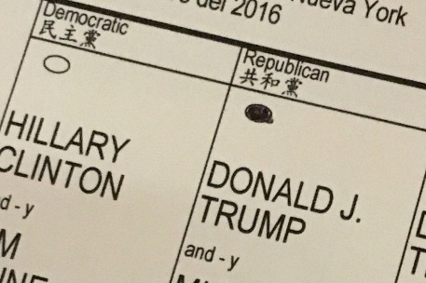Suzy threw the ball to Matthew.  
He’s useless at sport; he can’t even catch a ball.  
Just try to concentrate on hitting the ball.  
She kicked the ball so powerfully that it flew over the hedge.  
My golf was terrible today - I just didn't strike the ball well.  
The kids were outside playing ball.

|  |
| --- |
| **ballot** |

***a system of voting, usually in secret, or an occasion when you vote in this way***

The party leader is elected by a secret ballot.  
Workers at the plant held a ballot and rejected strike action.  
He was elected by a ballot of all the teaching staff in the college.  
It was decided to hold a ballot of all party members.

|  |
| --- |
| **ban** |

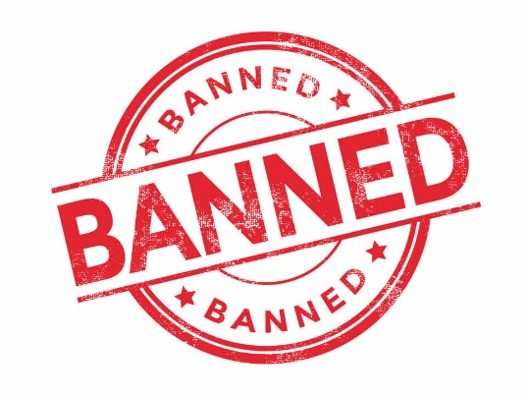He has also banned the use of foreign currencies for all domestic contracts.  
They are seeking a complete ban on nuclear testing.

|  |
| --- |
| **banana** |

I only had a banana for lunch.  
Could you chop up a banana for the fruit salad?

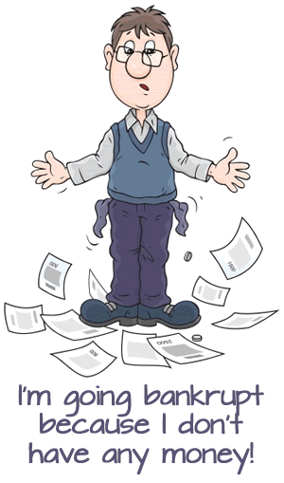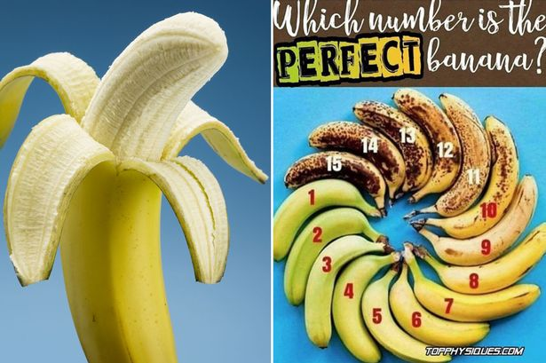

|  |
| --- |
| **bankrupt** |

He went bankrupt after only a year in business.  
The recession has led to many small businesses going bankrupt.

|  |
| --- |
| **bankruptcy** |

The company was forced into bankruptcy.  
The toll of bankruptcies was rising daily.

|  |
| --- |
| **bargain** |

***something on sale at a lower price than its true value:***  
This coat was half-price - a real bargain.  
The airline regularly offers last-minute bookings at bargain prices.  
There are no bargains in the clothes shops at the moment.

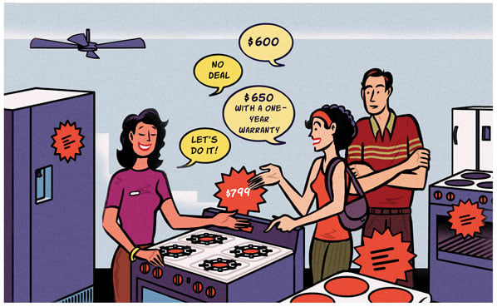

***an agreement between two people or groups in which each promises to do something in exchange for something else:***  
"I'll clean the kitchen if you clean the car." "OK, it's a bargain."  
The management and employees eventually struck/made a bargain (= reached an agreement).

***to try to make someone agree to give you something that is better for you, such as a better price or better working conditions:***  
Unions bargain with employers for better rates of pay each year.

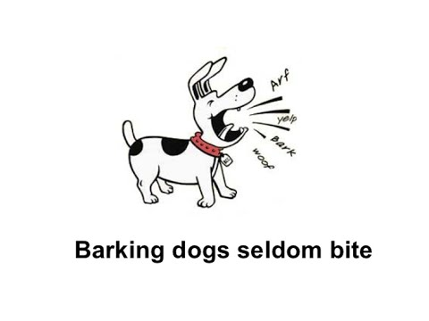

|  |
| --- |
| **bark** |

They heard a dog barking outside.  
Barking dogs seldom bite.

|  |
| --- |
| **barrier** |

Problems with childcare remain the biggest barrier to women.  
The mountains form a natural barrier between the two countries.  
Living in China was hard for me at first because of the language barrier.  
Most of the technical barriers have been solved.  
Passengers are requested to show their tickets at the barrier.

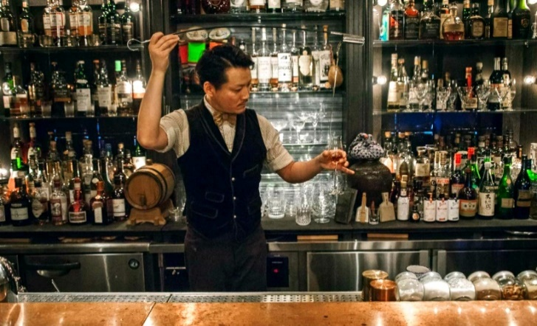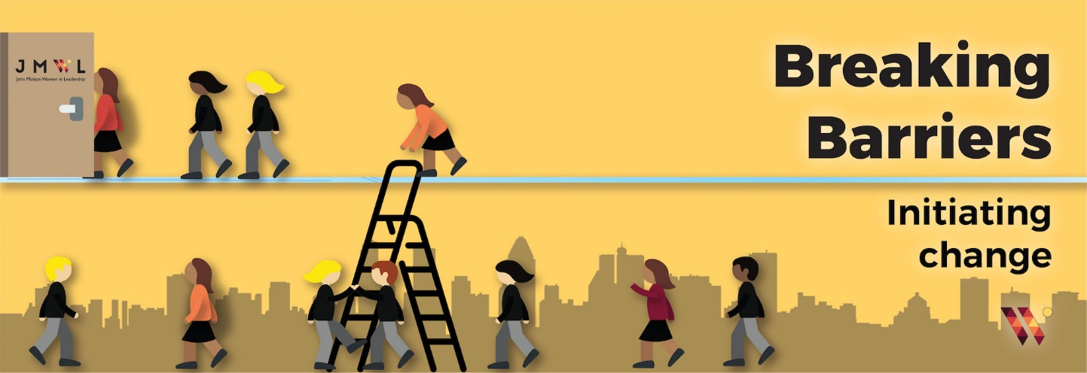

|  |
| --- |
| **bartender** |

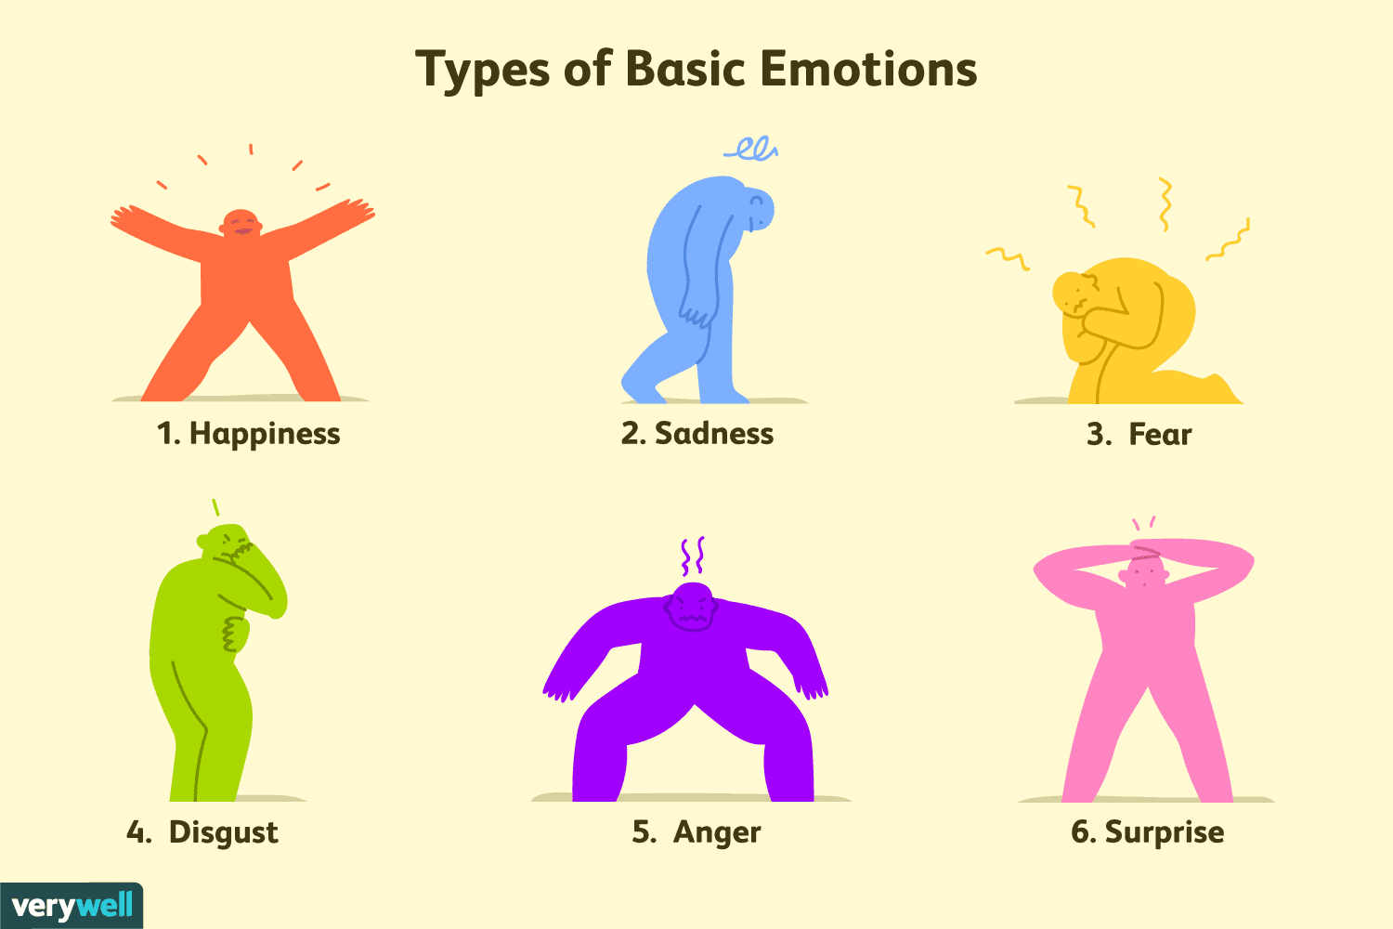Waiters and waitresses provide the service to the guests and work under a bartender.

|  |
| --- |
| **basic** |

Visit our website for some basic facts about healthy eating, exercise and weight control.  
Water – indeed everything basic to life here must be brought in by truck.  
people's basic needs

|  |
| --- |
| **bat** |

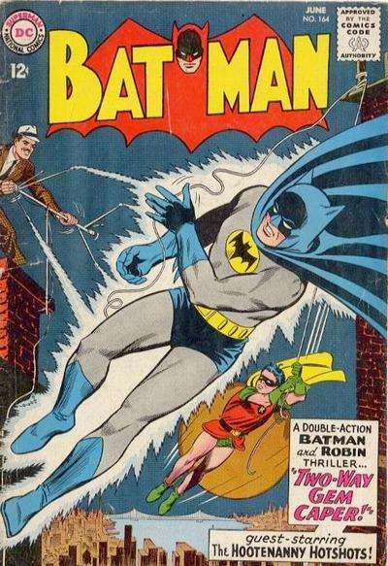***a small animal like a mouse with wings that flies at night***

|  |
| --- |
| **bathroom** |

Where’s the bathroom?  
I really need to go to the bathroom (=use a toilet).

He got up and went to the bathroom, took a shower.

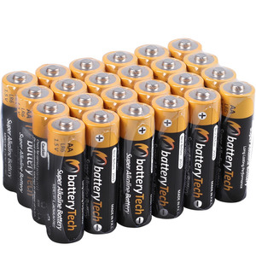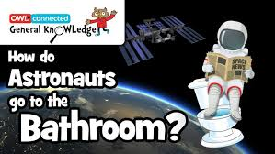

|  |
| --- |
| **battery** |

This alarm clock takes two medium-sized batteries.  
I think the battery is dead/flat (= has lost its power).  
You'll run the battery down if you leave your car lights on.  
I left my car lights on all night and now the battery is flat.

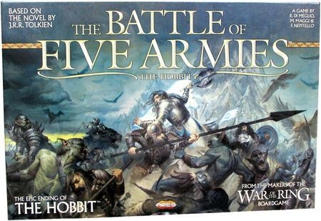

|  |
| --- |
| **battle : war** |

It’s essential to win the battle against inflation.  
Her only brother was killed in battle (= while fighting).  
Firefighters battled the flames.  
She had battled against cancer.

|  |
| --- |
| **bazaar** |

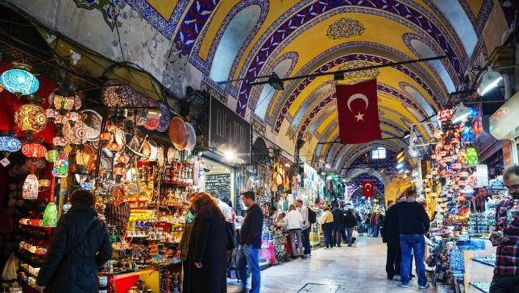Our school is having its springtime bazaar next Saturday.  
There are several historic bazaars in the city, together with many ultra-modern shopping malls.  
I visited the İstanbul and spent hours in Grand Bazaar.

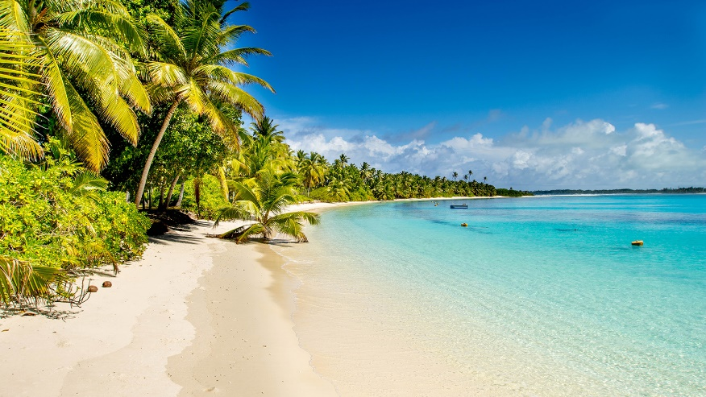

|  |
| --- |
| **beach** |

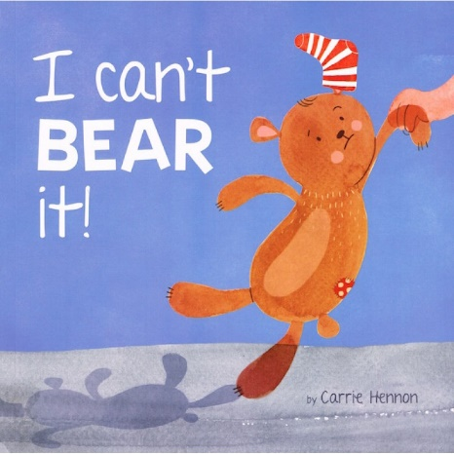***an area of sand or small stones near the sea or another area of water such as a lake:***  
We spent the day on the beach.  
There is a beautiful sandy beach.  
It's a nice day for going to the beach.  
We walked along the beach.  
Our hotel was right next to the beach.

|  |
| --- |
| **bear** |

She was afraid she wouldn’t be able to bear the pain.  
I couldn’t stand the noise any longer.  
Please don’t leave me. I couldn’t bear it.

***In everyday English, people usually say that they can’t stand something, rather than that they can't bear it:***

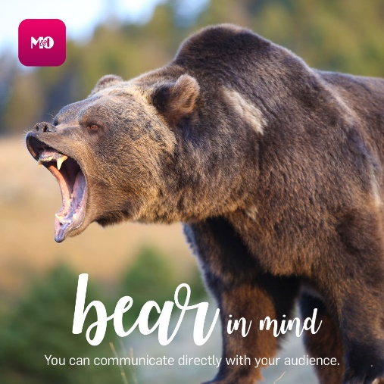Bear in mind that some children will need help.  
Thanks, I'll bear that in mind.

|  |
| --- |
| **beard** |

He's growing a beard.  
He shaved off his beard but kept his moustache.  
Graham came back from holiday with a week's growth of beard on his chin.

|  |
| --- |
| **beat** |

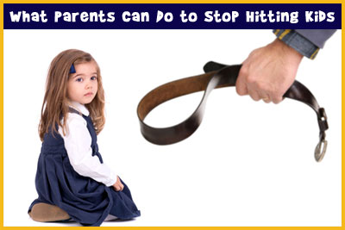Simon always beats me at tennis.  
Holland beat Belgium (by) 3–1.

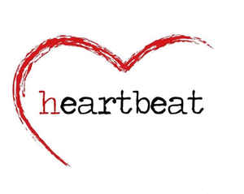They saw him beating his dog with a stick.  
The child had been brutally/savagely beaten.

The doctor could feel no pulse beating.  
Her heart started to beat faster.

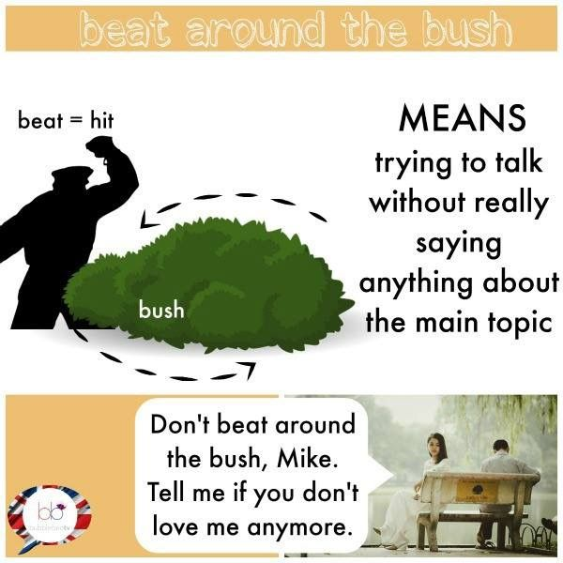***beat around the bush***  
***(uk also beat about the bush)***  
​  
*to avoid talking about what is important:*

Don't beat around the bush - get to the point!

|  |
| --- |
| **beautiful** |

Grace Kelly was a very beautiful woman.  
She was wearing a beautiful dress.  
I thought she was the most beautiful woman I’d ever seen.  
The scenery around here is beautiful.

|  |
| --- |
| **beauty** |

She said that people are now spending money on beauty and wellness because they realise it is good for them.  
With her beauty and charm, she captivated film audiences everywhere.  
The beauty of this plan (= what makes it good) is that it won't cost too much.

|  |
| --- |
| **because** |

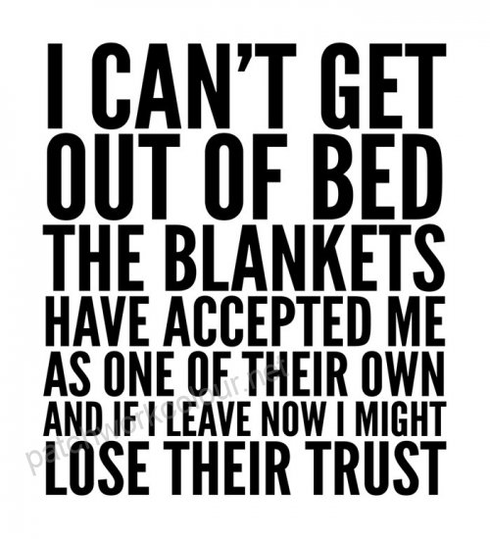"Why did you do it?" "Because Carlos told me to".  
We can't go to Julia's party because we're going away that weekend.  
Just because I'm lending you my dress for tonight doesn't mean you can borrow it whenever you want to.  
Where've you been, because (= the reason I am asking is that) we haven't seen you recently?

|  |
| --- |
| **bed** |

He likes to have breakfast in bed on a Saturday morning.  
She didn't get out of bed till lunchtime today.  
I'm exhausted - I'm going to bed (= going to get into a bed in order to sleep).  
I didn't even have the energy to get out of bed.  
I want to finish off this essay before I go to bed.

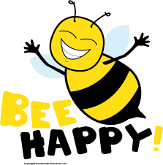

|  |
| --- |
| **bee** |

A swarm of bees flew into the garden.  
My arm swelled up where I was stung by a bee.

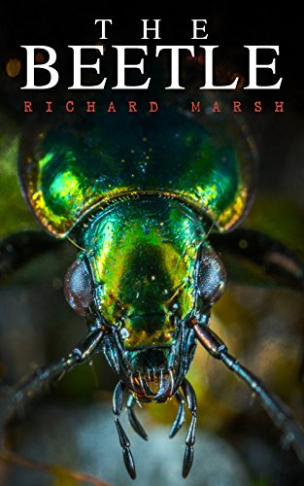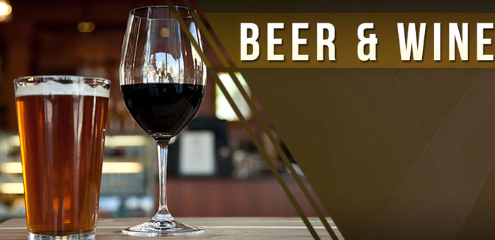

|  |
| --- |
| **beer** |

Let’s go and have a beer in the pub.  
There's plenty more beer in the fridge.  
He'd already drunk four beers before I'd finished one.

|  |
| --- |
| **beetle** |

You know that story of the man who wakes up and finds he's turned into a beetle?

|  |
| --- |
| **beg** |

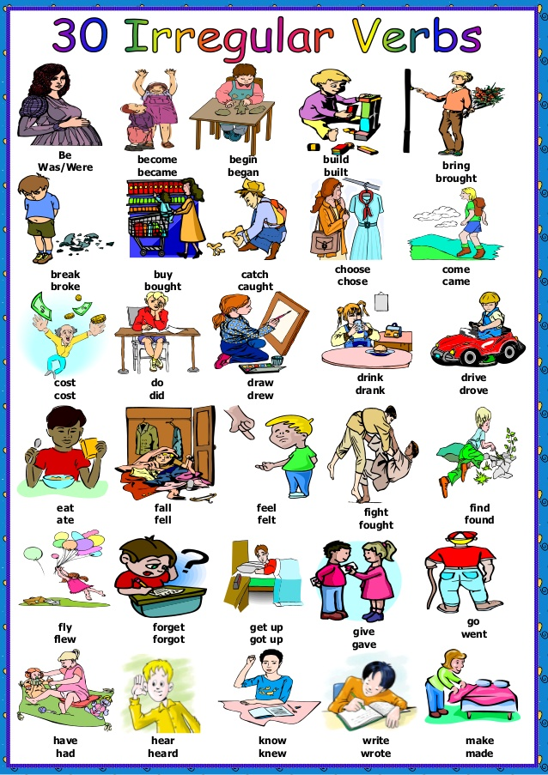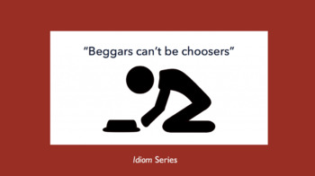There are more and more homeless people begging on the streets these days.  
They begged for mercy.  
I beg your pardon..

|  |
| --- |
| **beggar** |

**Beggars can't be choosers**, I suppose.

|  |
| --- |
| **begin : start** |

What time does the concert begin?  
The bridge was begun five years ago and the estimated cost has already doubled.  
The film they want to watch begins at seven.

|  |
| --- |
| **beginning** |

She’s been here since the beginning of the year.  
There’s a short poem at the beginning of every chapter.  
From the beginning of my career as a journalist, I’ve been writing about gender issues.  
The whole trip was a disaster from beginning to end.  
He had been lying to me from the very beginning.

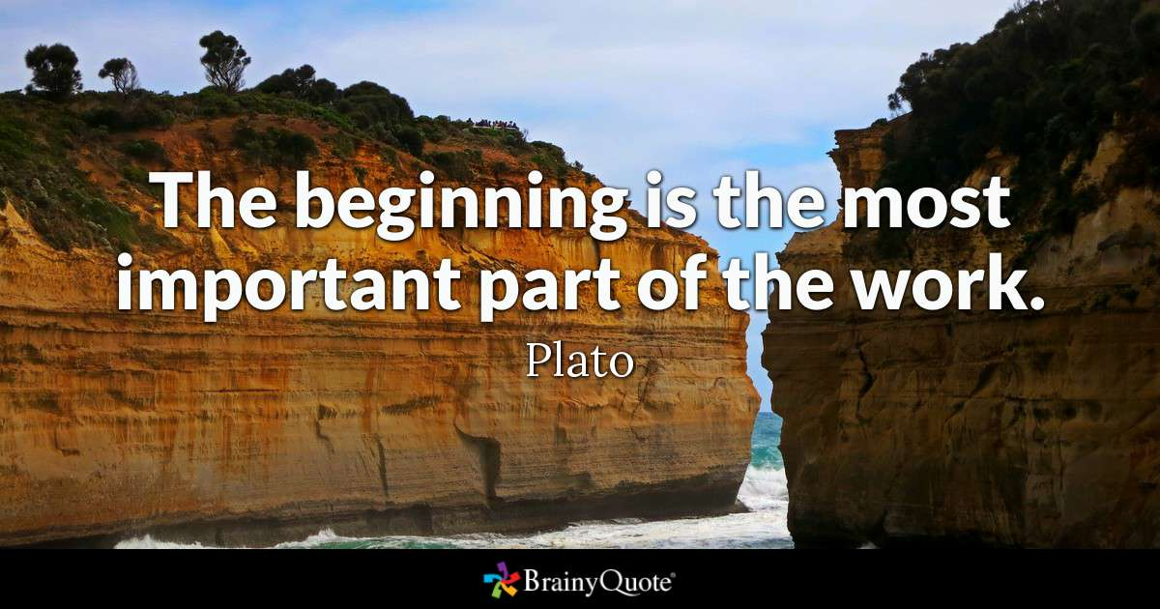

|  |
| --- |
| **on behalf of somebody** |

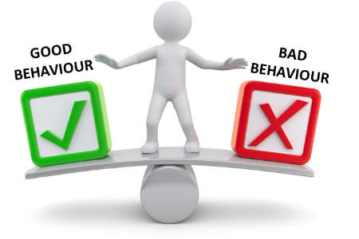On behalf of the entire company, I would like to thank you for all your work.  
Unfortunately, George cannot be with us today so I am pleased to accept this award on his behalf.  
She wasn't able to be present, so I signed the letter in her behalf.

|  |
| --- |
| **behave** |

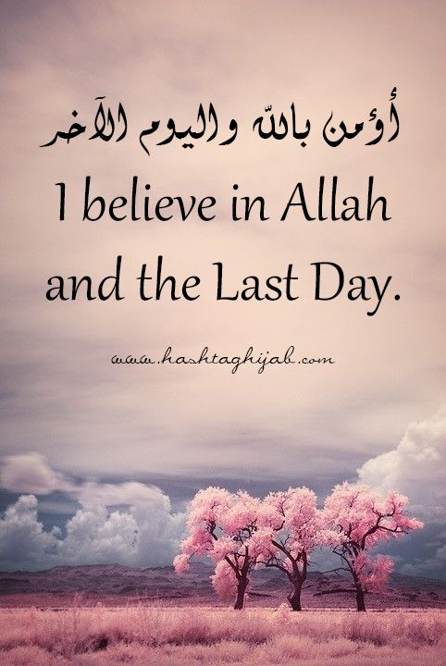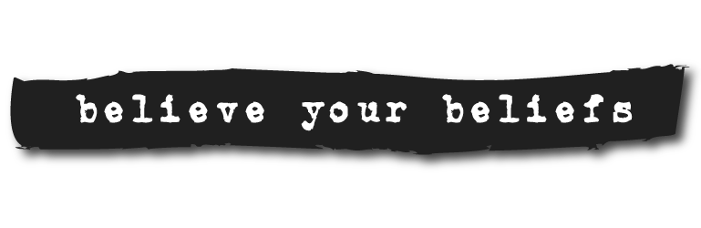They behaved as if nothing had happened.  
He was a little boy, but he behaved as if he was an adult.  
I’m not going to talk to her until she starts behaving reasonably.  
Oh, be quiet! You’re behaving like a two-year-old.

|  |
| --- |
| **behaviour** |

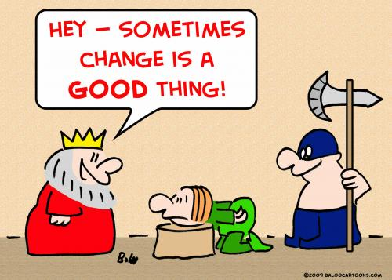Her behaviour is often shocking.  
He was notorious for his violent and threatening behaviour.

|  |
| --- |
| **behead** |

***to cut off someone's head, especially as a punishment***

Charles I was beheaded in 1649.

|  |
| --- |
| **belief** |

***the feeling of being certain that something exists or is true:***

His belief in God gave him hope during difficult times.  
Recent scandals have shaken many people's belief in (= caused people to have doubts about) politicians.

​  
***something that you believe:***

All religious and political beliefs should be respected equally.  
[ + that ] It is my (firm) belief that nuclear weapons are immoral.  
He called at her house in the belief that (= confident that) she would lend him the money.

|  |
| --- |
| **believe** |

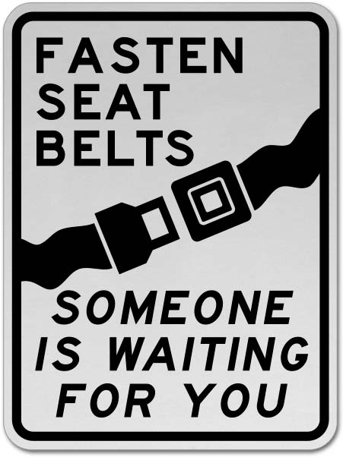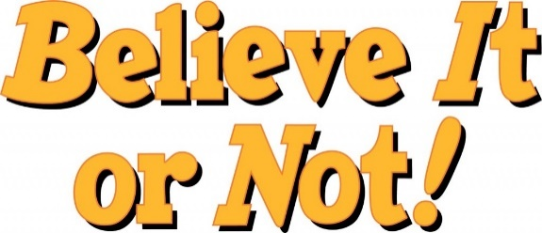He believes that all children are born with equal intelligence.

|  |
| --- |
| **belt** |

She fastened her belt tightly around her waist.  
He had eaten so much that he had to loosen his belt a couple of notches.  
The captain switched on the seat belt sign as we neared the airport.

|  |
| --- |
| **benchmark** |

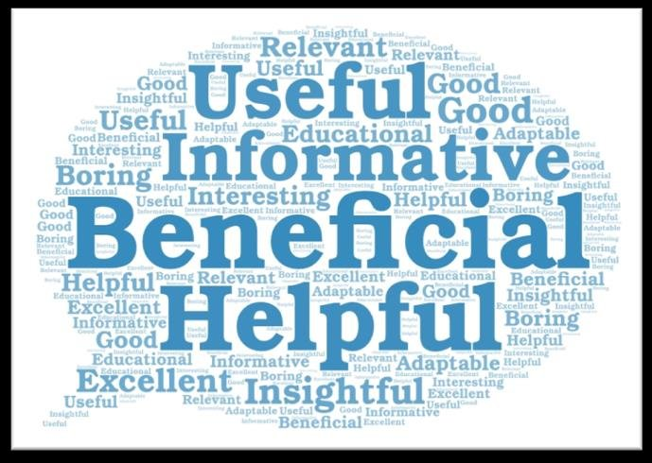*A benchmark is something whose quality or quantity is known and which can therefore be used as a standard with which other things can be compared.*  
The truck industry is a benchmark for the economy.

|  |
| --- |
| **benchmarking** |

In business, benchmarking is a process in which a company compares its products and methods with those of the most successful companies in its field, in order to try to improve its own performance.

|  |
| --- |
| **beneficial :helpful: useful** |

The psychiatric team decided that it would not be beneficial to keep her in hospital.  
Breast-feeding is extremely beneficial to the health of newborn babies.  
From our point of view, we do not see how these changes will be beneficial to the company.  
Only some bacteria are harmful - many are beneficial.

|  |
| --- |
| **benefit** |

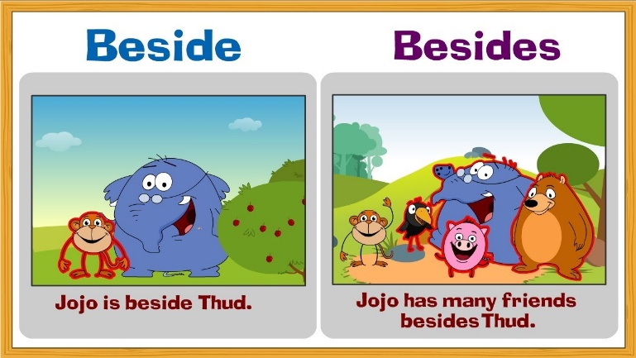I have benefited from the many good ideas which have been discussed in this conference.  
In addition to my salary, I get a pension and medical benefits.  
I didn't get/derive (much) benefit from school.

|  |
| --- |
| **beside : next to** |

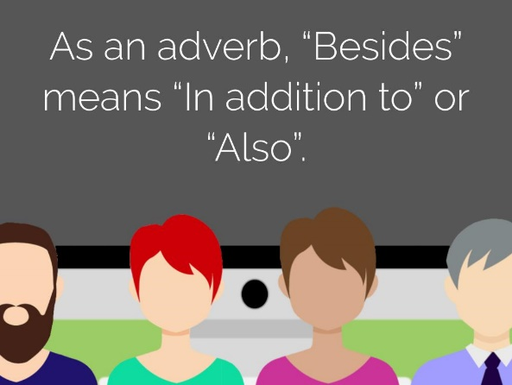Come and sit here beside me.

|  |
| --- |
| **besides: in addition to: also** |

She won't mind if you're late - besides, it's hardly your fault.  
Do you play any other sports besides basketball?

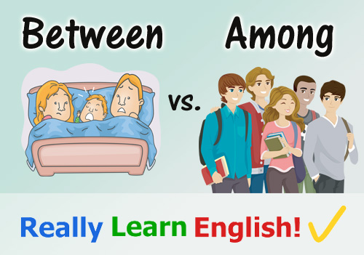

|  |
| --- |
| **between** |

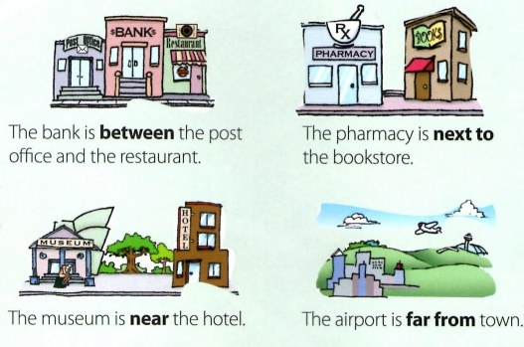The town lies **halfway** between Rome and Florence.  
*(Kasaba, Roma ve Floransa arasında yer almaktadır.)*  
Standing between the two adults was a small child.  
She squeezed between the parked cars and ran out into the road.  
There were two houses with a narrow path in between.

|  |
| --- |
| **beverage** |

Consumption of alcoholic beverages has increased dramatically.  
Hot beverages include tea, coffee, and hot chocolate.  
We do not sell alcoholic beverages.

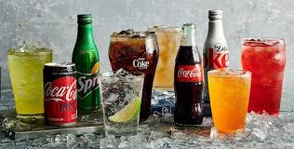

|  |
| --- |
| **bias** |

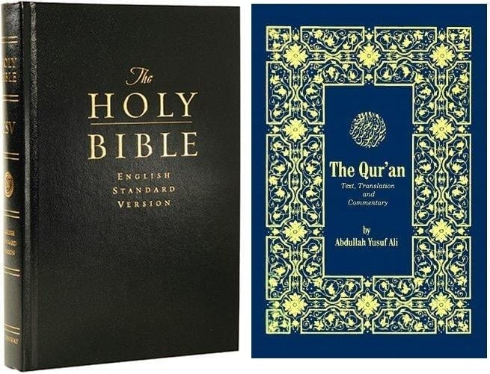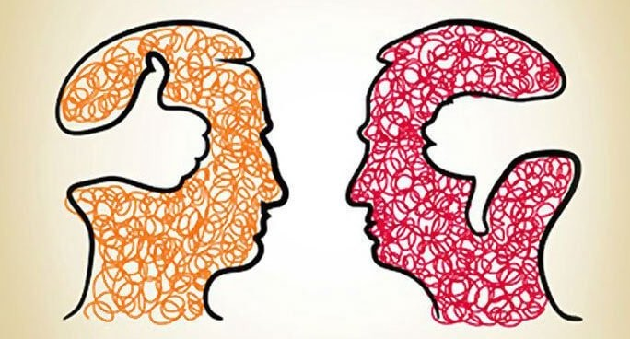Students were evaluated without bias.  
The senator has accused the media of bias.  
There was clear evidence of a strong bias against her.  
There was a clear racial bias in the selection of candidates.  
The teacher seems to have a bias towards the girls in her class.  
Do I Have an Unconscious Bias?

|  |
| --- |
| **Bible** |

The Bible says that Noah's ark landed on the mountains of Ararat. (5,137 m)

|  |
| --- |
| **bicycle : bike** |

I go to work by bicycle.  
You should never ride your bicycle without lights at night.

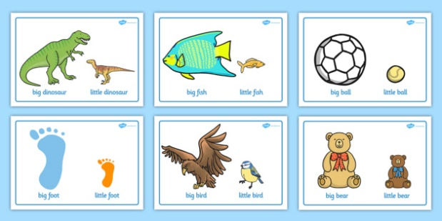

|  |
| --- |
| **big** |

They have a big house in the country.  
She has blonde hair and big blue eyes.  
The big windows make the room feel wonderfully light and airy.  
That jacket looks a bit big for you.

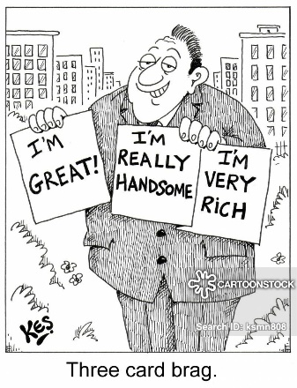

|  |
| --- |
| **bighead** |

***someone who thinks that they are more important or cleverer than they really are:***  
He's always boasting. He's such a bighead!  
I don't want to seem big-headed but I frankly don't think it will work.  
I don't want to sound big-headed, but I thought my picture was the best.

|  |
| --- |
| **bike : bicycle : motorbike** |

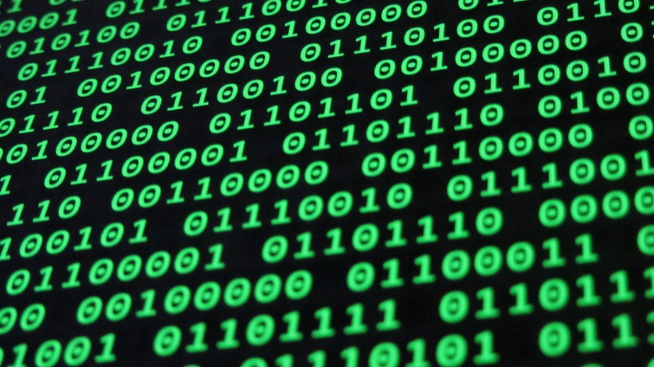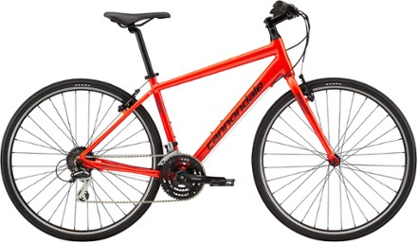It would be better for the environment if more people used bikes rather than cars.  
My youngest child is learning to ride a bike.

|  |
| --- |
| **binary** |

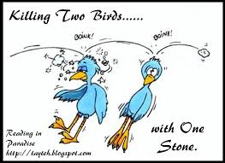***relating to a system of counting, used in computers, in which only the numbers 0 and 1 are used:***

|  |
| --- |
| **bird** |

The early bird catches the worm.  
I killed two birds with one stone and picked the kids up on the way to the station.   
A bird in the hand is worth two in the bush.

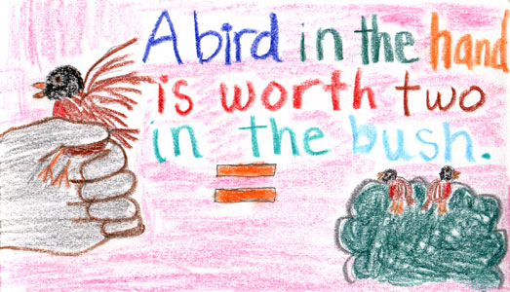

|  |
| --- |
| **bite** |

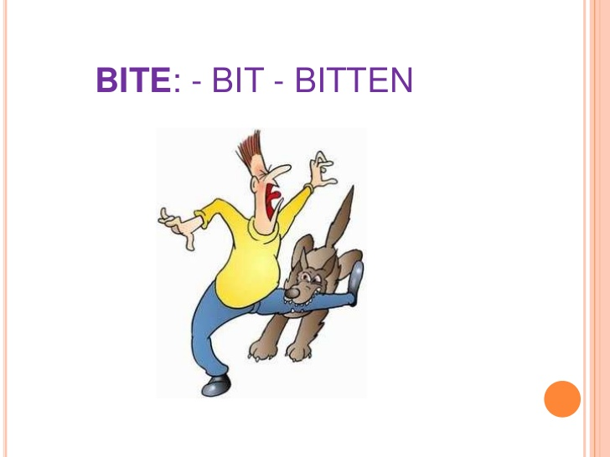He bites his fingernails.  
We were bitten by mosquitoes almost every night.

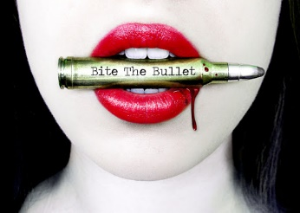

|  |
| --- |
| **bite the bullet** |

***to force yourself to do something unpleasant or difficult, or to be brave in a difficult situation:***  
I hate going to the dentist, but I'll just have to bite the bullet.  
I decided I had to bite the bullet and take a couple of math classes even though I knew they were hard.

|  |
| --- |
| **bizarre** |

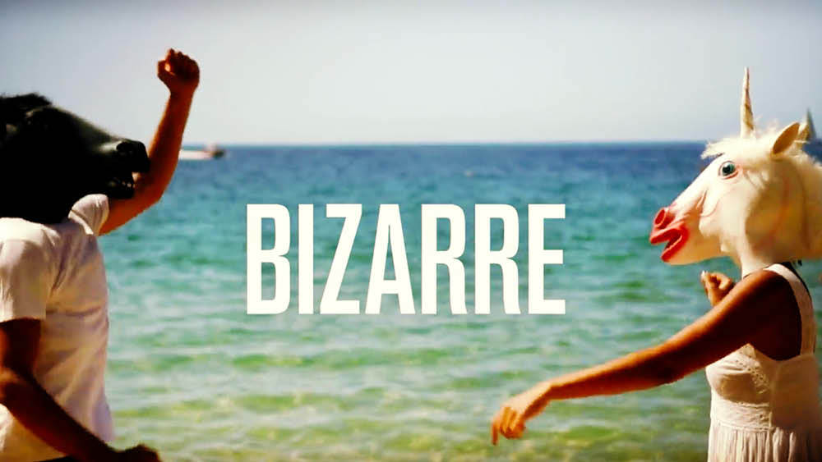The marriage between the two stars was as bizarre as it was short-lived.  
They tell the most bizarre stories about him.  
What she was saying was rather bizarre.  
A bizarre thought leaped into his mind.

|  |
| --- |
| **black** |

I wanted a simple black dress, nothing fancy.  
I heard a loud bang and then saw black smoke.  
The zebra is a wild African horse with black and white stripes.  
When you fill in the form, please write clearly in black ink

|  |
| --- |
| **blackmail : threaten** |

They used the photographs to blackmail her into spying for them.

|  |
| --- |
| **blame** |

Don't blame me if you miss the bus!

**Trump Says He Does Not Blame Turkey for Buying Russian Air Defense System.**

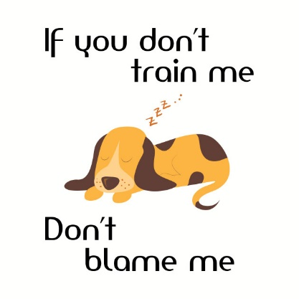

|  |
| --- |
| **blanket** |

Blankets are distinguished from sheets by their thickness and purpose; the thickest sheet is still thinner than the lightest blanket, because blankets are for warmth, while sheets are for hygiene, comfort and aesthetics.

|  |
| --- |
| **blind** |

Can you imagine how it feels to be blind?

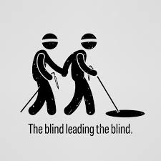

|  |
| --- |
| **blonde** |

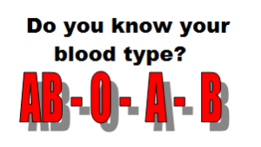There were two little girls, one Asian and one with blonde hair.  
The baby had blond curls.

|  |
| --- |
| **blood  /bılad/** |

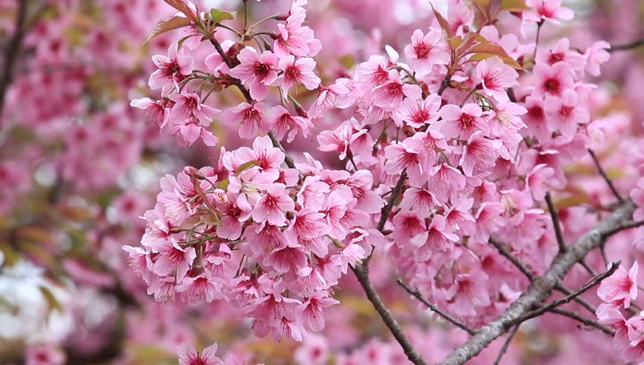She lost a lot of blood in the accident.  
The police found traces of blood on his jacket.

|  |
| --- |
| **bloom** |

**When a flower blooms, it opens or is open, and when a plant or tree blooms it produces flowers:**  
These flowers will bloom all through the summer.

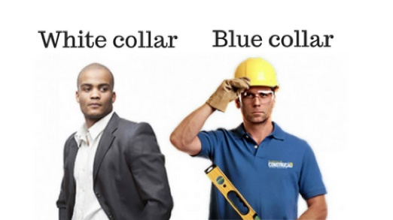**blue**

She's got fair hair and blue eyes.  
She wore a pale blue hat.  
For weeks we had cloudless blue skies.  
I caught a tantalizing glimpse of the sparkling blue sea through the trees.  
Police are looking for a small blue car with the registration number K17 EMW.

|  |
| --- |
| **blue-collar** |

***blue-collar workers do physical work, rather than working in offices***

|  |
| --- |
| **Blue Monday** |

Blue Monday is a name given to a date stated to be the most depressing day of the year.

|  |
| --- |
| **body** |

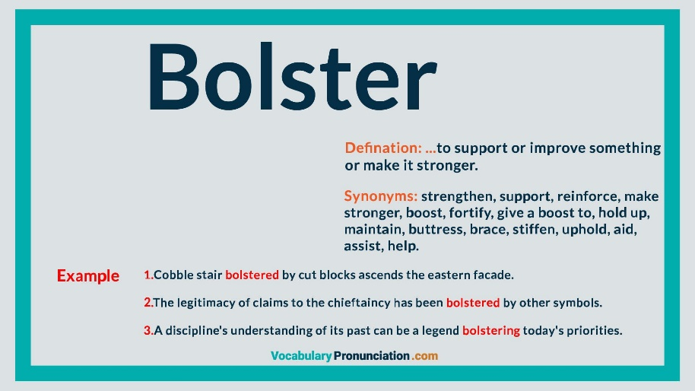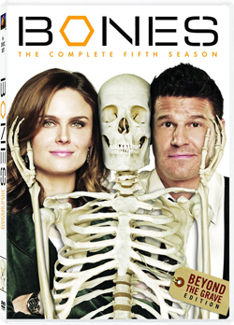A good diet and plenty of exercise will help you to keep your body healthy.  
She rubbed suncream over her entire body.  
He had a fat body but thin legs and arms.  
The human body is composed of about 60% water.  
Police had marked off the area where the body was found.

|  |
| --- |
| **bolster** |

***to help someone to feel better and more positive.***

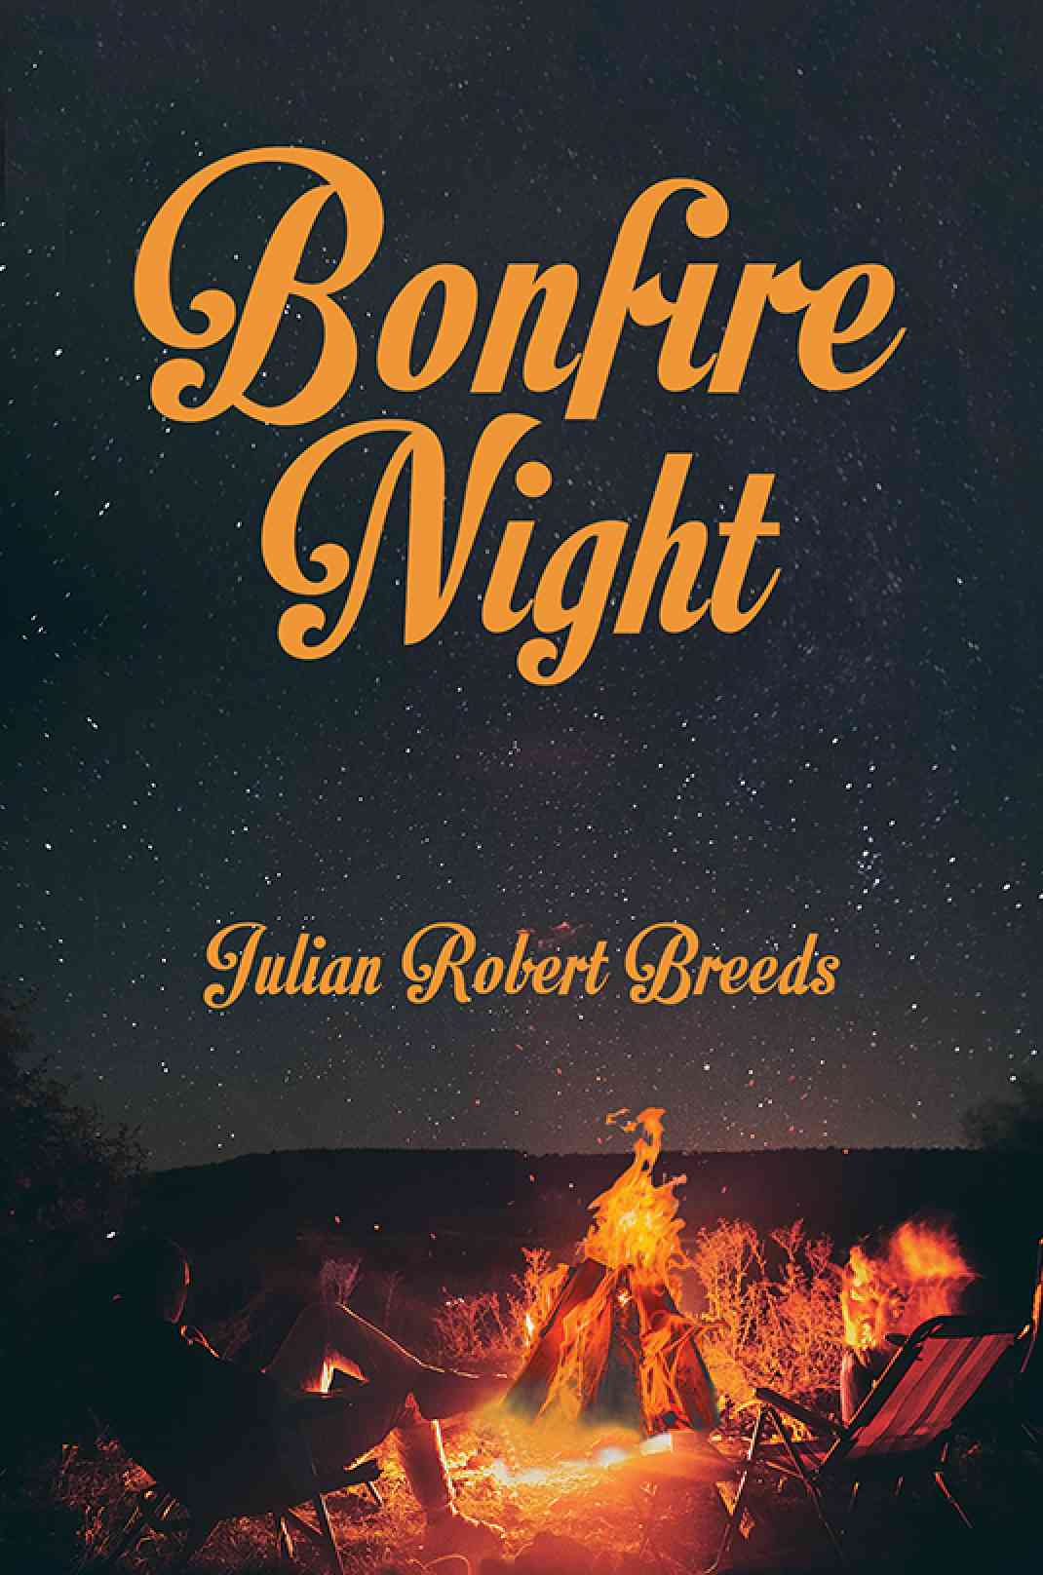***to support something, or make something stronger:***  
He is making a bold attempt to bolster the territory’s confidence.  
Timman needs to win a game to bolster his confidence.  
More money is needed to bolster the industry.  
The UN is sending more troops to bolster the peacekeepers.

|  |
| --- |
| **bone** |

The child was so thin that you could see her bones.  
I don't like fish because I hate the bones.  
She had broken a bone in her foot.

|  |
| --- |
| **bonfire** |

*A bonfire is a controlled outdoor fire used for informal disposal of burnable waste material or as part of a celebration.*  
Young people and children dance and sing round the bonfires.

|  |
| --- |
| **book** |

Have you read any good books recently?  
I took a book with me to read on the plane.  
In the last two years the book has only sold 200 copies.  
I have to return my library books on the sixth of July.

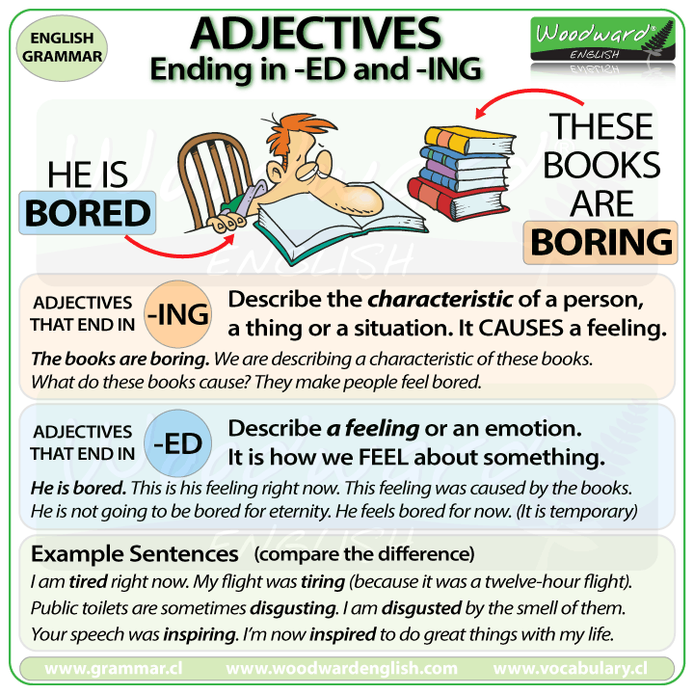She'd booked a table for four at their favourite restaurant.  
Will booked a seat on the evening flight to Los Angeles.  
We were advised to book early if we wanted to get a room.

|  |
| --- |
| **bookstore :  bookshop** |

***a store that sells books***

**border**

Were you stopped at the border?  
The train crosses the border between France and Spain.  
The two countries have had frequent border disputes.  
Thousands of troops have massed along the border in preparation for an invasion.  
Strasbourg is on the border of France and Germany.  
Illegal immigrants are sent back across the border if they are caught.  
The border guards stopped me and asked to see my papers.  
Checkpoint Charlie used to be the most famous border crossing between East and West Berlin.

|  |
| --- |
| **bored with** |

He was getting bored with/of doing the same thing every day.  
I enjoyed my job at/in the beginning, but I'm bored with it now.

|  |
| --- |
| **boring** |

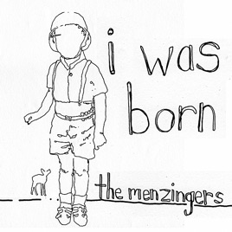She finds opera boring.  
Sometimes I enjoy my English lessons, but at other times I find them really boring.  
This programme's boring - shall I turn over to BBC?  
Your hair has a natural wave whereas mine's just straight and boring.  
This town is so boring in the evening - there's never anything happening.  
Life would be bloody boring if nothing ever went wrong.

|  |
| --- |
| **born** |

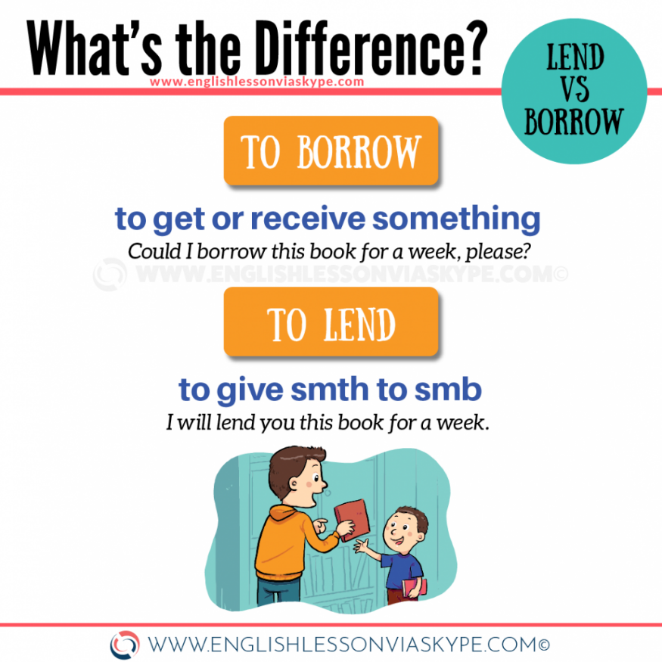Mike was born in 1950.  
Sonia was born into an aristocratic family.  
Katy was born and brought up in Delaware.

|  |
| --- |
| **borrow : lend** |

Can I borrow £100 off you until next week?  
She used to borrow money and not bother to pay it back.  
He borrowed a novel from the library.

**boss**

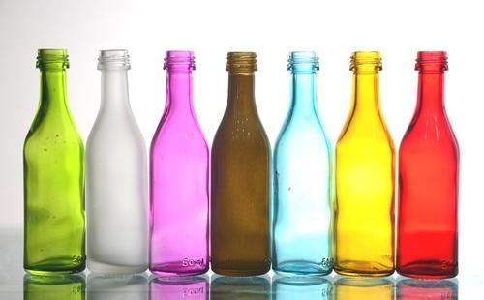I will be studying the report tomorrow when my boss arrives.  
John was the boss of a large international company.  
I **started up** my own business and now I'm my own boss (= I work for myself and no one tells me what to do).  
"How are you **getting on** with your new boss?" "Not bad."

|  |
| --- |
| **bottle** |

Plastic bottles are lighter than glass ones.  
Don't use all the milk, Dan - that's our last bottle.

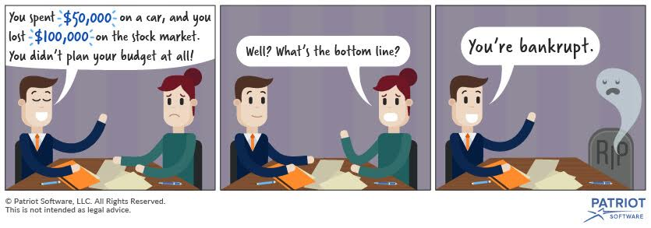

|  |
| --- |
| **bottom line** |

The bottom line is that we need another ten thousand dollars to complete the project.

|  |
| --- |
| **boundary : border** |

However, it was also the symbolic boundary between democracy and Communism during the Cold War.

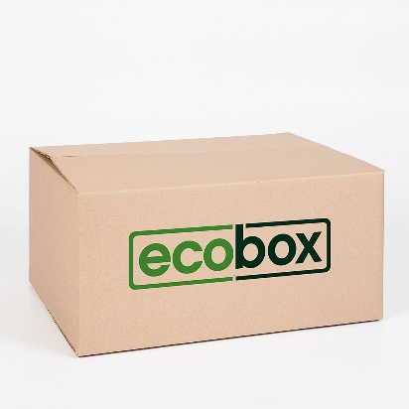*Your generosity has no boundaries.*

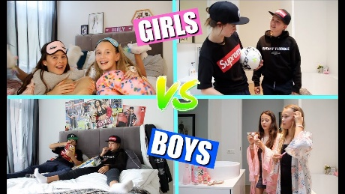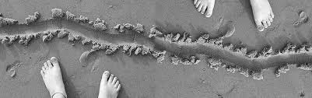

|  |
| --- |
| **box** |

I took her a box of chocolates.  
He lifted the box carefully down from the shelf.  
Put the empty box in the rubbish bin.  
I'm amazed you managed to move those heavy boxes all by yourself.  
I've got boxes of old clothes in the attic.

|  |
| --- |
| **boy** |

The boys wanted to play football.  
A group of teenage boys stood talking in a group outside.  
I love my boys, but I’d like to have a girl, too.

|  |
| --- |
| **brain** |

The accident left him with permanent brain damage.  
That can't possibly be the right way to do it - use your brain!



|  |
| --- |
| **brainstorming** |

The college is holding a brainstorming session to look at possible funding sources.  
Remember ideas are welcomed from groups - so start brainstorming!  
Sections and departments hold brainstorming sessions and posters are displayed to encourage the climate of innovation.

|  |
| --- |
| **brand-new** |

How can he afford to buy himself a brand new car?  
Her coat looked as if it was brand new.  
A man in a brand-new pick-up truck picked me up.

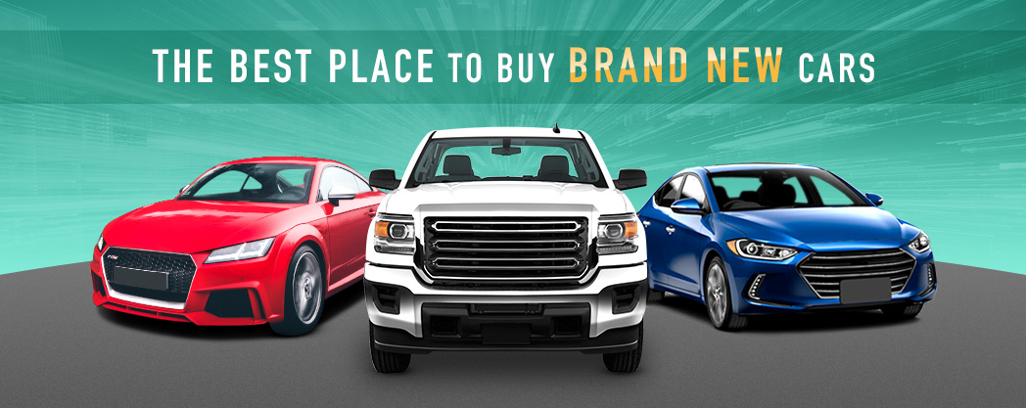

|  |
| --- |
| **brave** |

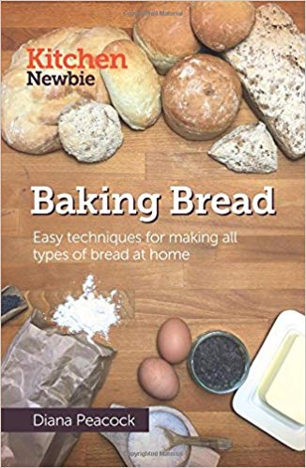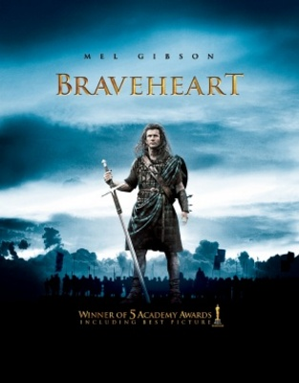"Chicken" is slang for someone who isn't very brave.  
It was brave of you to speak in front of all those people.  
I think he was incredibly brave to do a parachute jump.

|  |
| --- |
| **bread** |

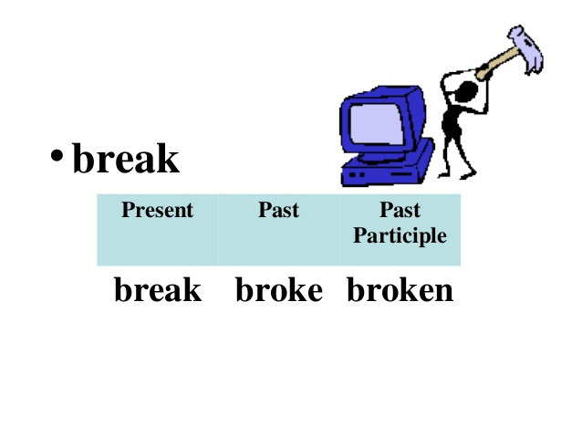Do you bake your own bread?  
Shall I cut you a slice of bread?  
There's nothing better than fresh bread, straight from the oven.

|  |
| --- |
| **break** |

She fell and broke her arm (= broke the bone in her arm).  
I dropped the vase and it broke into pieces.  
Take an egg and break it into the bowl.  
She broke her promise/word to me (= did not do what she promised she would).

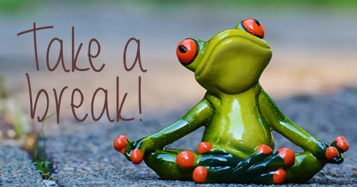

We'll take another break at 3.30.  
They worked through the night without a break.  
Do you usually take a morning/afternoon break?

|  |
| --- |
| **break down** |

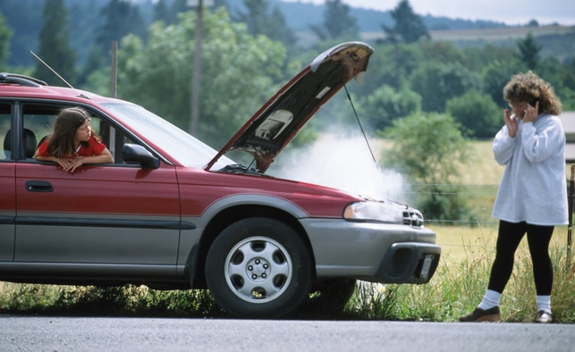Our car broke down and we had to push it off the road.  
The school bus broke down and had to be towed to the nearest garage.  
Oh no - has your washing machine broken down again?  
I'm worried that his car has broken down, or worse still, that he's had an accident.

***Break down*is a phrasal verb. It can mean either *to stop functioning* or *to separate a whole into constituent parts*.**

This math equation is easier if you break it down into several parts.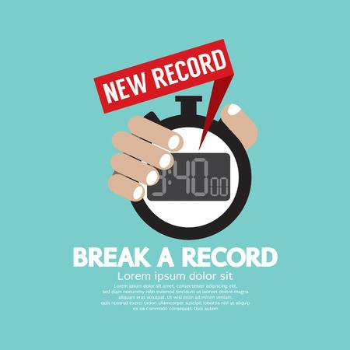

|  |
| --- |
| **break the record** |

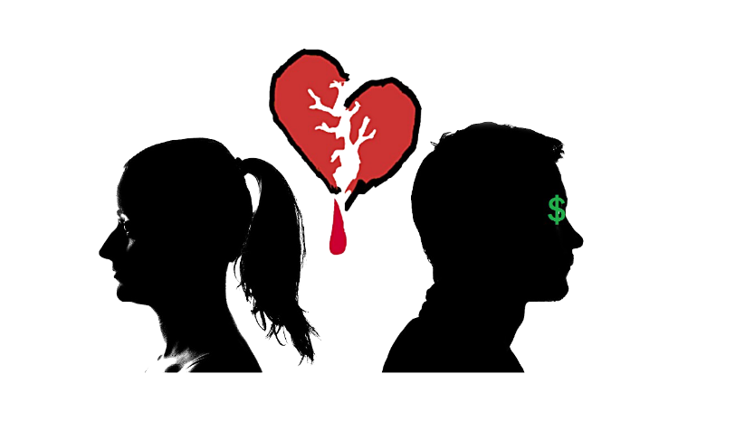She broke the record for the 5,000 metres.

|  |
| --- |
| **break up** |

*to end or cause something to end*  
Media reports said police used tear gas at the construction site on Friday to break up a protest by the workers who were demanding better conditions, including improved safety at the site.

*If a marriage breaks up or two people in a romantic relationship break up, their marriage or their relationship ends:*  
Jenny and George have broken up.  
She's just broken up with her boyfriend.

|  |
| --- |
| **breakdown** |

**a failure to work or be successful:**

I had a breakdown (= my car stopped working) in the middle of the road.  
Both sides blamed each other for the breakdown of talks.  
She suffered a nervous breakdown after the death of her child.  
Machine breakdowns occur regularly and repairs cost the company quite a lot of money.

|  |
| --- |
| **breakfast** |

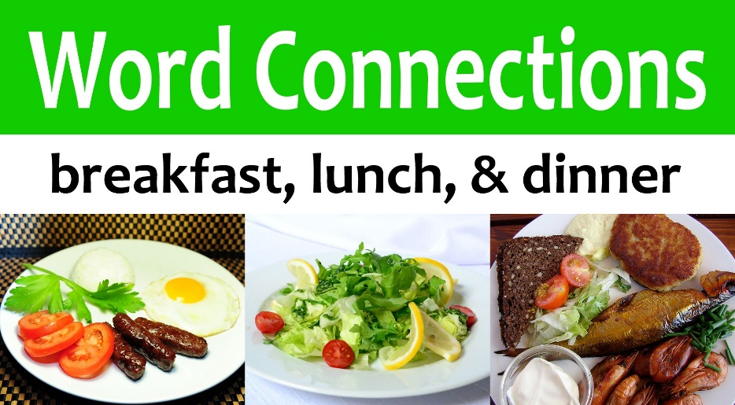What do you want for breakfast?  
Jane never eats breakfast.  
She arrived shortly after breakfast.  
Breakfast is served in the dining room from 8.30 till 10.00.

|  |
| --- |
| **breaking news** |

We'll bring you all the latest breaking news as it happens.  
Breaking news: the missing child from York has been found safe and well.

|  |
| --- |
| **breath** |

Take a deep breath.  
Leo could smell the wine on her breath.  
When he reached the top of the stairs, his heart was pounding and he was gasping for breath.  
Will he listen to me or will I just be wasting my breath?

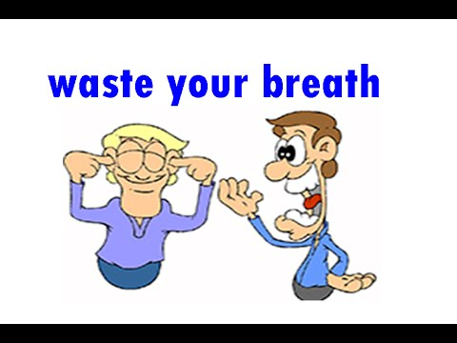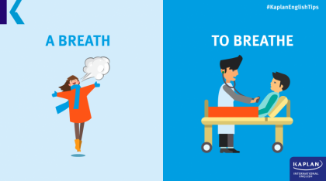

|  |
| --- |
| **breathe** |

When you breathe out, you expel air from your lungs.  
The atmosphere in the room was so stuffy I could hardly breathe.  
The firefighters wore respirators to help them breathe in the smoke-filled house.  
The doctors are doing all that they can, but she's still not breathing properly.  
I breathed in the crisp mountain air deeply.

|  |
| --- |
| **bribe** |

They bribed the waiter to find them a better table.  
He bribed the children with sweets and pocket money not to tell their mum what he'd done.  
He bribed immigration officials and entered the country illegally.

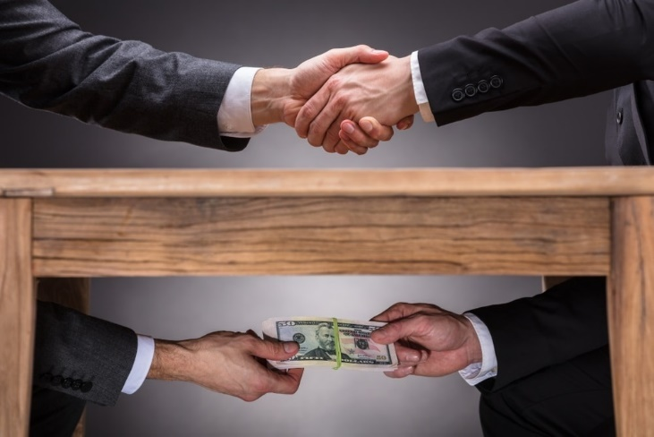

|  |
| --- |
| **bribery** |

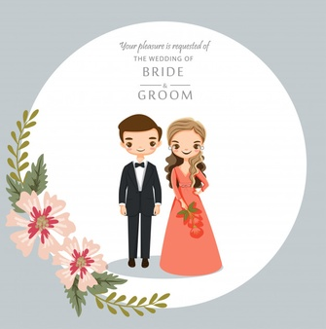We tried everything – persuasion, bribery, threats.  
He was found guilty of bribery and corruption (=bribery and dishonest behaviour).

|  |
| --- |
| **bride/groom** |

Future brides and bridegrooms are often referred to as fiancées or fiancés respectively. (anılan sıraya göre)  
The bridegroom (groom) was late for the ceremony.

|  |
| --- |
| **brilliant** |

She closed her eyes against the brilliant (very bright) light.  
I think that’s a brilliant (clever) idea.  
Joanna came up with a brilliant idea for a new book.  
She's brilliant at handling difficult clients.  
The film was absolutely brilliant (excellent).  
He had a long and brilliant (very successful) career.



|  |
| --- |
| **bring** |

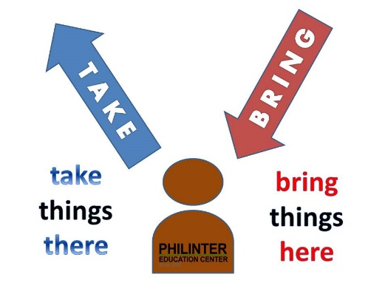"Shall I bring anything to the party?" "Oh, just a bottle."  
Bring me that knife/Bring that knife to me.  
When they visit us they always bring their dog with them.  
Is it okay if I bring a friend to the party?

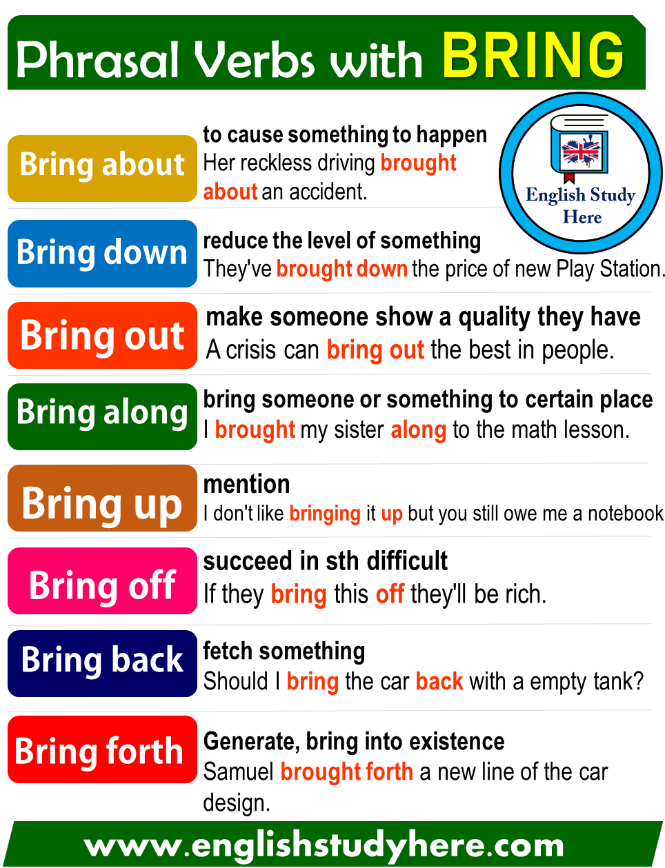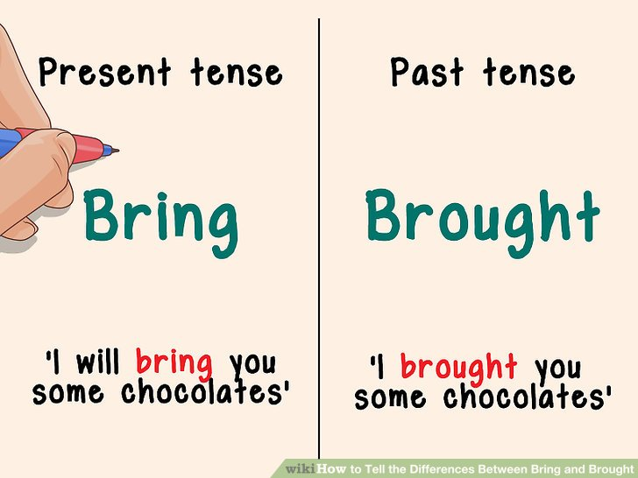

|  |
| --- |
| **bring about** |

**to cause something to happen:**  
He brought about his company's collapse by his reckless spending.  
How can we bring about a change in attitudes?  
A huge amount of environmental damage has been brought about by the destruction of the rainforests.

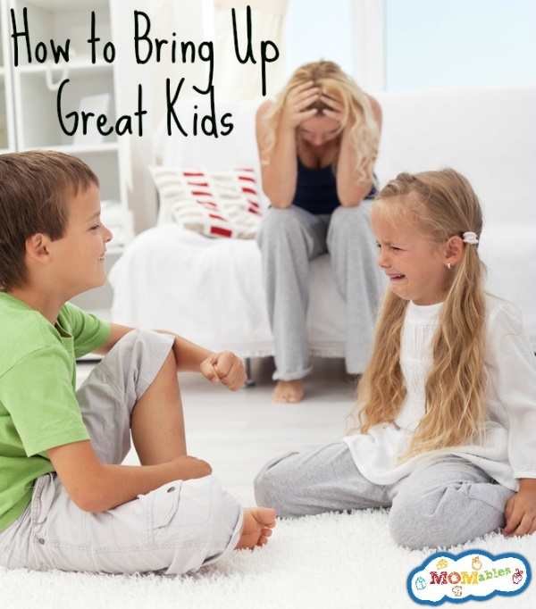

|  |
| --- |
| **bring up** |

He was brought up by his grandparents.  
Upon his grandfather's death in 578, Muhammad, aged about eight, passed into the care of a paternal uncle, Abu Talib. Muhammad grew up in the older man's home and remained under Abu Talib's protection for many years.

I hate to bring up business at lunch.  
Why did you have to bring up the subject of money?

|  |
| --- |
| **broad** |

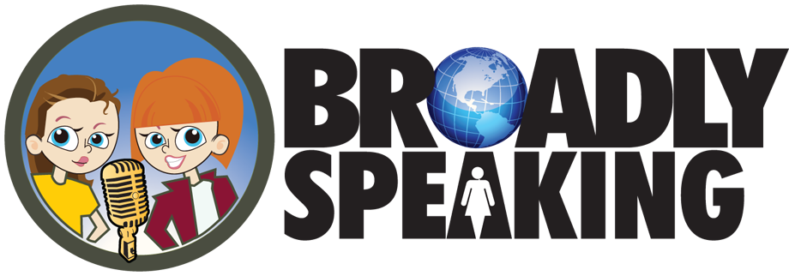My brother is very broad-shouldered.  
This river is over 500 metres broad at its widest point.  
Amy had a broad smile on her face.  
The magazine covers a broad range of subjects, from sewing to psychology.  
He explained it in very broad terms.

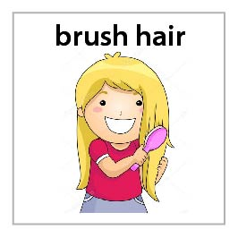**Broadly speaking**, we agree about most things.  
***used for saying that something is true in the most important ways***

|  |
| --- |
| **brush** |

When did he last brush his teeth, she wondered.  
She brushed her hair with long, regular strokes.

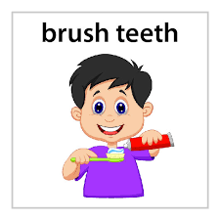

|  |
| --- |
| **bubble gum** |

***a type of chewing gum that you can blow into a bubble***

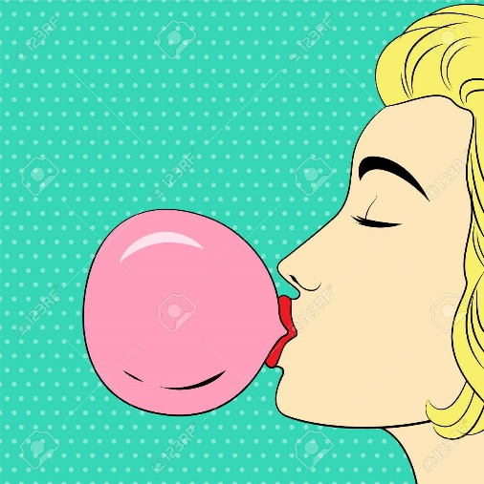

|  |
| --- |
| **buck : deer (çoğul:bucks)** |

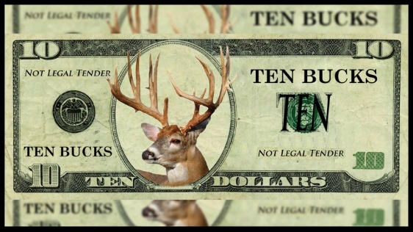Can I borrow a couple of bucks?  
He charged me 20 bucks for a new hubcap.

STARBUCKS



|  |
| --- |
| **bull** |

They did not see the sign by the gate saying "Beware of the bull".  
Our herd has two bulls and twenty cows.

|  |
| --- |
| **bullet** /bulit/ |

The bullet went clean through his shoulder.  
She cried out in pain as the bullet grazed her shoulder.  
The bullet entered the body at chest height.  
The houses in the village were pockmarked with bullet holes.

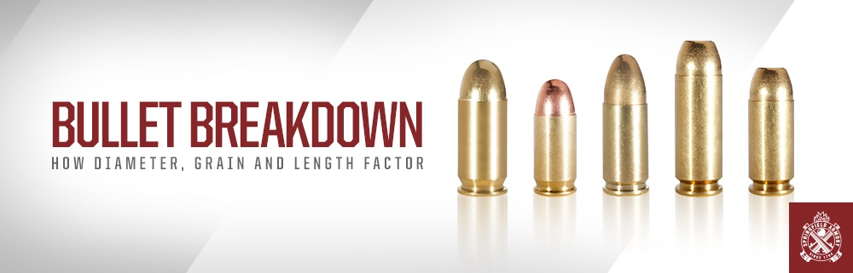

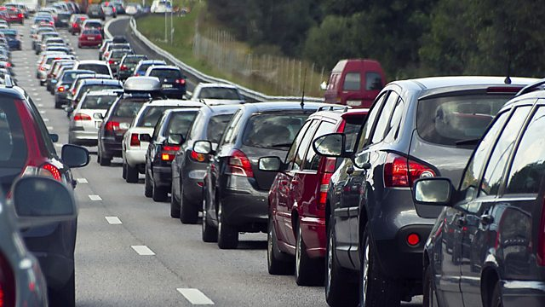

|  |
| --- |
| **bumper** |

By eight o'clock the traffic was bumper to bumper.  
The traffic was bumper to bumper all the way home.

|  |
| --- |
| **bunny : rabbit** |

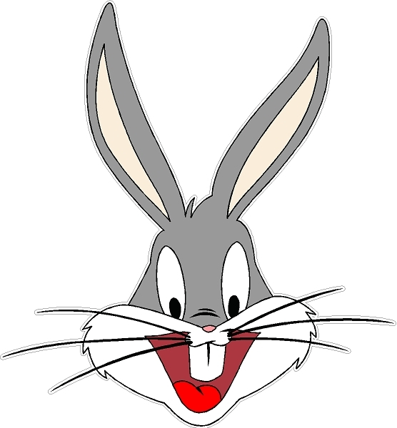*Bunny*is another noun and another name for a *rabbit*, but it usually refers to a young rabbit, often a baby rabit*.*

|  |
| --- |
| **burglar** |

It was brave of you to chase after the burglar.

|  |
| --- |
| **burn** |

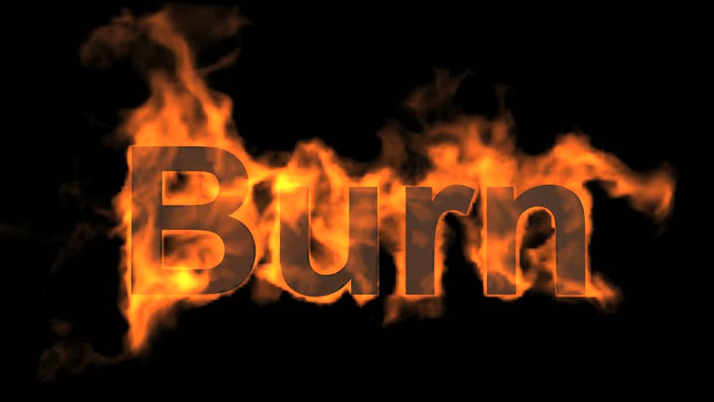He was badly burned in the blaze.  
She burned his old love letters.  
The brandy burned (= felt too hot on) my throat.  
On her first day in the Caribbean Josie was badly burned (= her skin became red and painful from too much sun).  
Fair-skinned people burn easily in the sun.

Burn your favourite songs or your important files onto CDs.

|  |
| --- |
| **burn bridge** |

If you get mad and quit your job, you'll be burning your bridges behind you.

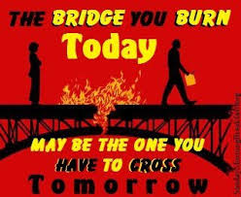

|  |
| --- |
| **burnout** |

*the feeling of always being tired because you have been working too hard*  
Many of the teachers are suffering from burnout.

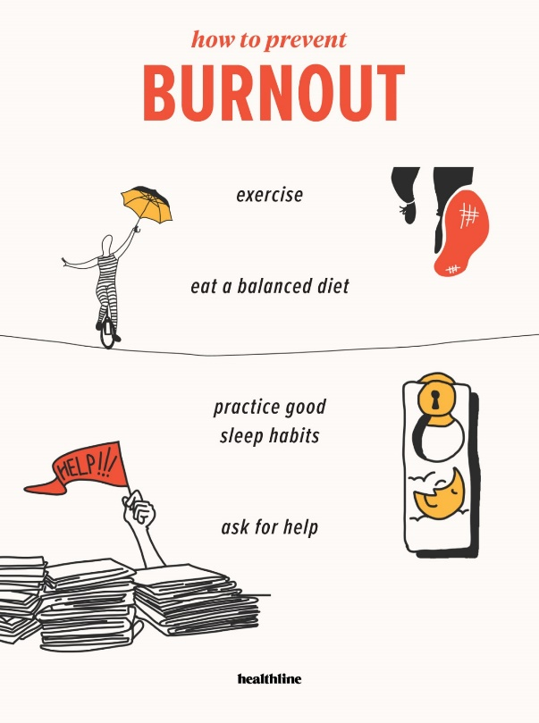

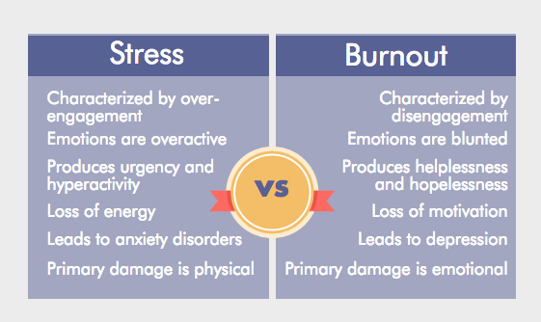



|  |
| --- |
| **burst** |

I hate it when balloons burst.  
Suddenly the door burst open (= opened suddenly and forcefully) and police officers rushed in.

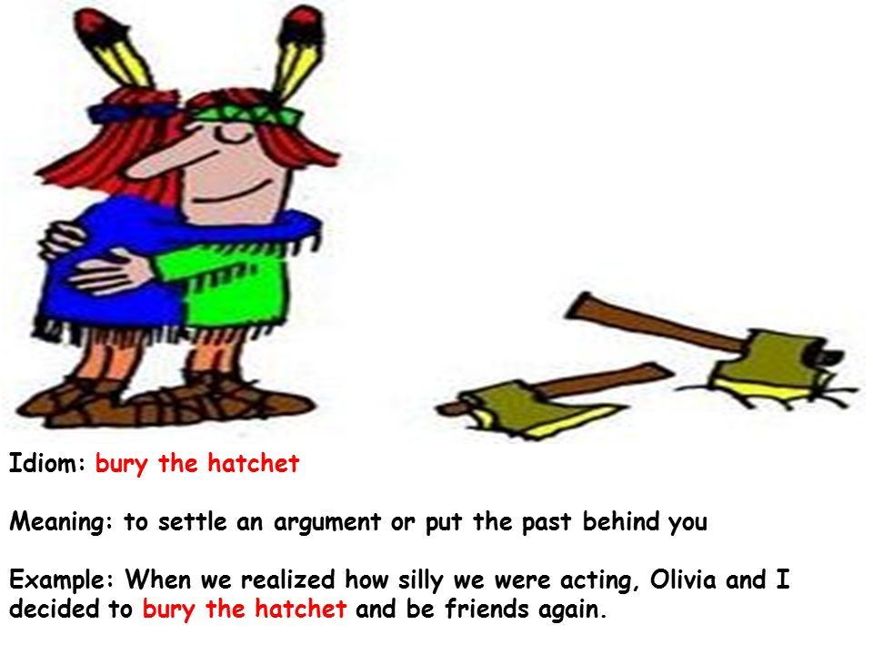  
The river was threatening to burst its banks.  
If I eat any more cake I'll burst (= I cannot eat anything else)!

|  |
| --- |
| **bury** |

His father is buried in the cemetery on the hill.  
Squirrels bury nuts and dig them up later to eat them.  
When we realized how silly we were acting, Olivia and I decided to bury the hatchet and be friends again.

|  |
| --- |
| **bus** |

You should take the bus/go by bus (= travel by bus) if you want to see the sights.

|  |
| --- |
| **bush** |

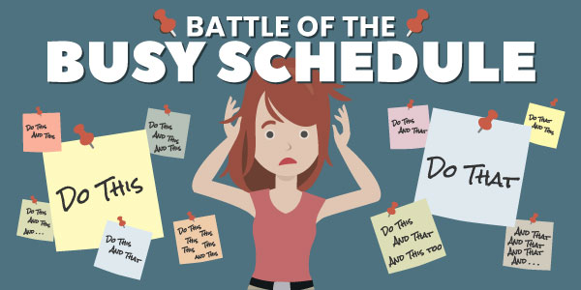The meadow was covered with small bushes and grass.  
The child was hiding in the bushes.

|  |
| --- |
| **busy** |

Mum was busy in the kitchen.  
The kids are busy with their homework.  
She's busy writing out the wedding invitations.  
I've got plenty of jobs to keep you busy.

|  |
| --- |
| **but : however** |

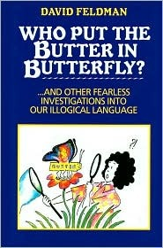I'm sorry, but I think you're wrong when you say she did it deliberately.  
She's not only a painter but also a writer (= she is both).  
We ran after him, but he escaped.  
We enjoyed our vacation a lot, but it was expensive.

|  |
| --- |
| **butter** |

We were served scones with butter and jam.  
scone: (a small unsweetened or lightly sweetened cake made from flour, fat, and milk and sometimes having added fruit)  
Have some bread and butter (= bread spread with butter).

|  |
| --- |
| **butterfly** |

These flowers are brightly coloured in order to attract butterflies.  
Some butterflies blend in with their surroundings so that it's difficult to see them.

|  |
| --- |
| **buy** |

He bought some flowers for his girlfriend.  
Eventually she had saved enough money to buy a small car.

accept the truth of; to believe that something is true:  
She'll never buy that story about you getting lost!  
"I am not prepared to buy the claim that the ends justify the means"



|  |
| --- |
| **by accident** |

*without intending to, or without being intended:*

I deleted the file by accident.  
I found her letter by accident as I was looking through my files.

|  |
| --- |
| **by heart** |

You know the telephone number by heart, don't you?

